Lab Standard Operating Procedure
Phenol Chloroform Extractions
Table of Contents
Overview 1
Potential Chemical Hazards 2
Engineering and Ventilation Controls 5
Required Personal Protective Equipment 5
Procedure 7
Additional Precautions 7
Safety References 8
Waste Disposal 8
Emergency Procedures 8
Chemical Spill 8
Fire 9
References 9

Overview

Principal Investigator: _______________________
Department: ______________________________
Room & Building: ___________________________
Research Group: ____________________________

Potential Chemical Hazards
Chemical | Hazards | Pictograms | Comments
Phenol | - Corrosive  - Acutely toxic  - Mutagenic  - Combustible  - Aquatic toxicity | 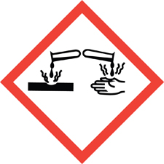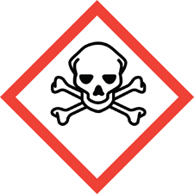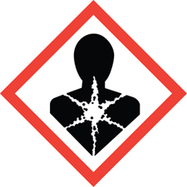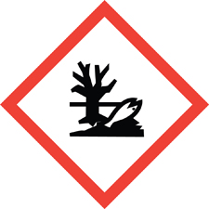 | Phenol is readily absorbed through the skin and can cause severe burns to the eyes and skin.  It is toxic if swallowed, in contact with skin, or if inhaled.  Systemic effects include damage to the liver and kidneys. Rinse contacted areas with a large volume of water and wash with soap and water for at least 15 minutes.  Labs using phenol should have polyethylene glycol (PEG) available (PEG300 or PEG 400) to treat dermal exposures. Refer to the Phenol Minor Skin Exposure Kit document for recommendations.
Trizol (30-60% phenol with 30% thiocyanate compound) | - Corrosive  - Irritant  - Acutely toxic  - Combustible  - Shock sensitive | 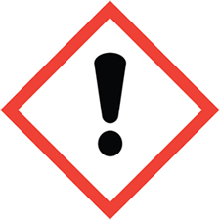 | Trizol is corrosive to the eyes and may cause severe damage including blindness.  Causes severe burns to eyes, nose, skin, throat, lungs, and stomach. It is toxic by inhalation or if swallowed.  May damage the nervous system, kidneys, liver, or pancreas through repeated or prolonged exposure.
Chloroform | - Irritant  - Reproductive toxin  - Carcinogen |  | Adding chloroform to phenol enhances the ability of phenol to be absorbed by the skin.  Systemic effects include damage to the liver and central nervous system.
Hydrochloric acid | - Corrosive |  | Handle with care as concentrated hydrochloric acid is used.  Highly corrosive and causes severe burns on eye and skin contact and upon inhalation of the vapor.
Isoamyl alcohol | - Irritant  - Flammable | 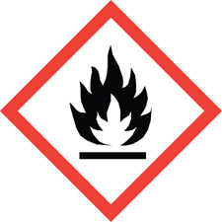
Ether | - Shock sensitive  - Flammable |  | Ether is extremely flammable and forms explosive peroxides after prolonged exposure to light and air.  Refer to the Lab Safety Guideline: Peroxide Forming Chemicals for more information.
Ethanol | - Flammable
Isopropanol | - Irritant  - Flammable
Beta-mercaptoethanol | - Corrosive  - Toxic  - Skin sensitizer  - Reproductive toxicity |  | Strong, unpleasant odor.  Treat contaminated solids and sharps as hazardous chemical waste.

Engineering and Ventilation Controls
All procedures involving the transfer of phenol, chloroform, Trizol, or other phenol-containing solutions should be performed in a chemical fume hood. Contact EH&S if work outside of a fume hood may be required.

Required Personal Protective Equipment
Refer to your lab’s Personal Protective Equipment (PPE) Assessment Report, supplemented with information here.
The level of skin and eye protection should be selected based on the potential for splashing and other forms of exposure. Wear a combination of clothing and shoes that fully cover the legs and feet when handling hazardous chemicals, including phenol.
Minimum potential for splash and exposure:
- Chemical splash goggles.
- Chemical resistant gloves.
- Choose gloves based on the level of chemical protection and dexterity needed. Refer to the Safety Data Sheet (SDS) for each chemical to be used and the EH&S Lab Glove Selection Guide for help in identifying compatible gloves.
- A single pair of neoprene rubber gloves are recommended for phenol work. However, they may be bulky.
- Double nitrile gloves or nitrile and neoprene combination gloves (example: Ansell 93-260) are acceptable for work with small volumes or low splash risk but note that there is a shorter breakthrough time. Double-gloving is recommended, given the diversity of chemical hazards and highly corrosive chemicals involved. Consider a different color and glove material with each layer.
- Immediately replace with new gloves when splash occurs. Place contaminated gloves in a hazardous chemical waste container.
- Protective clothing, such as impervious lab coat, sleeves, and closed-toed footwear.
When using or transferring large quantities, or for spill clean-up:
- Chemical splash goggles.
- Heavier gloves made of polyvinyl alcohol (PVA), double neoprene rubber gloves, Silver Shield, or Ansell 2-100.
- Double-gloving is recommended, given the diversity of chemical hazards and highly corrosive chemicals involved. Consider a different color and glove material with each layer to provide protection against a wider range of chemicals.
- Immediately replace with new gloves when splash occurs.
- Chemical resistant, impervious apron, smock, or lab coat (polyethylene (PE), polyvinyl chloride (PVC), natural rubber, neoprene, or Silver Shield) that ties from behind.
- Avoid using the traditional cotton-polyester white lab coat, which readily collects and absorbs compounds.
- Protective clothing, such as sleeves, impervious boots or PVC disposable shoe coverings, and closed-toed footwear.

Procedure
Instructions: Either enter the lab-specific experimental protocol or protocols for phenol chloroform extractions here or attach to this SOP.

Additional Precautions
Review the Lab Safety Guideline documents for phenol and chloroform before working with those chemicals.
When centrifuging material:
- Use plastic bottles and tubes instead of glass to reduce the risk of breakage.
Note that chloroform and phenol can degrade some types of plastics. Check the chemical resistance or compatibility of materials selected prior to use. Teflon fluorinated ethylene propylene/polytetrafluoroethylene/perfluoroalkoxy (FEP/PTFE/PFA) is recommended.
- Plan to use aerosol-proof rotors or safety caps during centrifugation to ensure aerosol containment, knowing a centrifuge tube may break while spinning. Wait at least 10 minutes before opening the centrifuge to allow aerosols to settle.
Keep liquid phenol containers tightly closed and away from heat and light. Store away from inorganic acids and oxidizers (such as chlorine, bromine, and calcium hypochlorite).
Chloroform reacts violently with alkali metals such as potassium and sodium, a mixture of acetone and base, or a strong base such as potassium and sodium hydroxide, potassium t-butoxide, sodium methoxide, or sodium hydride. It reacts explosively with fluorine and dinitrogen tetroxide. In the presence of light, chloroform undergoes autoxidation to generate phosgene. This can be minimized by storing chloroform in the dark, under nitrogen. Store in manufacturer’s original container when possible. Do not store in aluminum containers.

Safety References
Additional chemical safety information, including SDSs and other information, is available electronically as tools at Safe Chemical Work Practices.

Waste Disposal
Dispose of waste as hazardous chemical waste. Refer to the Laboratory Waste Guide.

Emergency Procedures
Refer to the Emergency Response Guide, supplemented with information here.

Chemical Spill
- For small spills, proceed with cleanup if trained. If not trained, the lab doesn’t have the needed spill materials, or if uncomfortable with attempting spill cleanup, call the Operations Center at 617-495-5560. Harvard Medical School (HMS) and Harvard Dental School of Medicine (HSDM) labs should call 617-432-1901.
- If proceeding with cleanup, follow chemical spill response PPE guidelines in the PPE section. Don protective clothing, extinguish all ignition sources, and carefully apply vermiculite or other appropriate spill absorbent material to the spill. Place in a durable and sealable container for disposal as hazardous chemical waste.
- For spill clean-ups, use PVA gloves (chemical breakthrough time greater than 8 hours).
Do not wear nitrile gloves (with a breakthrough time of a few minutes), due to the risk of direct or prolonged contact when cleaning up a spill.
- Respiratory protection may be necessary in the event of a large spill or release in a confined area.
- For a large spill, release in a confined area, or where respiratory protection may be needed, evacuate the lab, deny further entry, and call the Operations Center at 617-495-5560. HMS and HSDM labs should call 617-432-1901.

Fire
- In the event of fire, evacuate and bar further entry. Activate fire alarm and leave the building.

References
- Lab Safety Guideline – Chloroform
- Lab Safety Guideline – Phenol
- Phenol Minor Skin Exposure Kit Instructions (Contact the group’s Lab Safety Advisor for a copy.)
- J. Sambrook, E. F. Fritsch, T. Maniatis, “Purification of Nucleic Acids,” Molecular Cloning: A Laboratory Manual, 2nd ed., Cold Spring Harbor Laboratory Press, 1989, pE.3-4.
- G. D. Clayton, F. E. Clayton, Patty’s Industrial Hygiene and Toxicology, 3rd ed., Wiley-Interscience Publication, John Wiley & Sons, Inc., 1981, p2567-84.

