Full Chemical Name:  Date  - 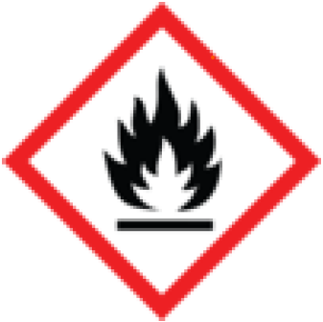 IGNITABLE/FLAMMABLE  - 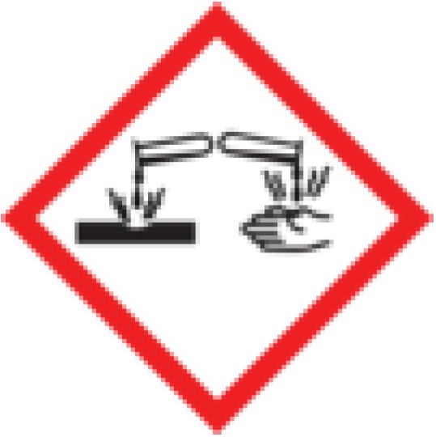 CORROSIVE  - 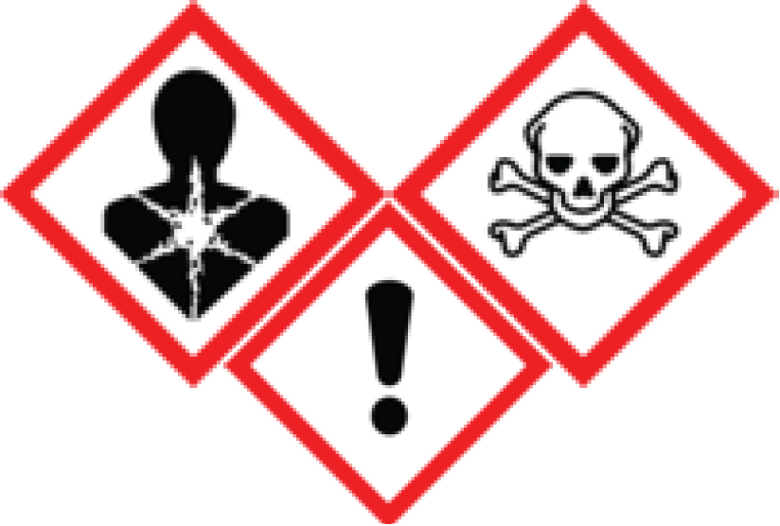 TOXIC/POISON  - OXIDIZER  - OTHER: _______________ |  | Full Chemical Name:  Date  - IGNITABLE/FLAMMABLE  - CORROSIVE  - TOXIC/POISON  - OXIDIZER  - OTHER: _______________ |  | Full Chemical Name:  Date  - IGNITABLE/FLAMMABLE  - CORROSIVE  - TOXIC/POISON  - OXIDIZER  - OTHER: _______________
Full Chemical Name:  Date  - IGNITABLE/FLAMMABLE  - CORROSIVE  - TOXIC/POISON  - OXIDIZER  - OTHER: _______________ |  | Full Chemical Name:  Date  - IGNITABLE/FLAMMABLE  - CORROSIVE  - TOXIC/POISON  - OXIDIZER  - OTHER: _______________ |  | Full Chemical Name:  Date  - IGNITABLE/FLAMMABLE  - CORROSIVE  - TOXIC/POISON  - OXIDIZER  - OTHER: _______________
Full Chemical Name:  Date  - IGNITABLE/FLAMMABLE  - CORROSIVE  - TOXIC/POISON  - OXIDIZER  - OTHER: _______________ |  | Full Chemical Name:  Date  - IGNITABLE/FLAMMABLE  - CORROSIVE  - TOXIC/POISON  - OXIDIZER  - OTHER: _______________ |  | Full Chemical Name:  Date  - IGNITABLE/FLAMMABLE  - CORROSIVE  - TOXIC/POISON  - OXIDIZER  - OTHER: _______________
Full Chemical Name:  Date  - IGNITABLE/FLAMMABLE  - CORROSIVE  - TOXIC/POISON  - OXIDIZER  - OTHER: _______________ |  | Full Chemical Name:  Date  - IGNITABLE/FLAMMABLE  - CORROSIVE  - TOXIC/POISON  - OXIDIZER  - OTHER: _______________ |  | Full Chemical Name:  Date  - IGNITABLE/FLAMMABLE  - CORROSIVE  - TOXIC/POISON  - OXIDIZER  - OTHER: _______________

